**Prokaryotic Showdown**

**Progress Report 11/15/2012**

* **Functional Minimum**  **(complete)**
  + Our functional minimum layer will be a single player survival game where the objective of the game is to survive. **(complete)**
  + The world will consist of resources which the player should collect in order to grow and multiply. **(complete)**
  + Each grow and multiply action will cost some resource points. **(complete)**
  + The world will also consist of threats such as viruses that move about in the world. **(complete)**
  + The bacteria will have health and die if their health reaches zero. **(complete)**
  + Players need to accomplish objectives such as maintaining some amount of resource points for a particular length of time, or grow the population up to a certain level etc. to win the game. **(complete)**
* **Low target**
  + Players build up their resources (resource points) and use them to create more bacteria and to level up their bacteria. **(complete)**
  + The world map will be a battle ground where 2 players will grow their respective bacteria population and try to exterminate the other population for dominance.
  + It will be turn-based.
* **Desired Target**
  + A larger, interesting world with a lot more variety of resources and threats.
  + Players can choose among multiple races of bacteria, each having unique abilities.
  + Players will be able to upgrade their bacteria and become stronger. **(complete)**
  + Upgrades may include health, resistance to diseases, faster movement etc. **(complete)**
* **High Target**
  + Players can choose among more than one world to play in.
  + The game will have a Fog of War (FOW) which will make the world more mysterious.
  + All the resources and enemies will be hidden on the map and will be revealed as the player explores the world.
* **Extra**
  + Make the game a real time strategy game instead of turn based.
  + Online Multiplayer.

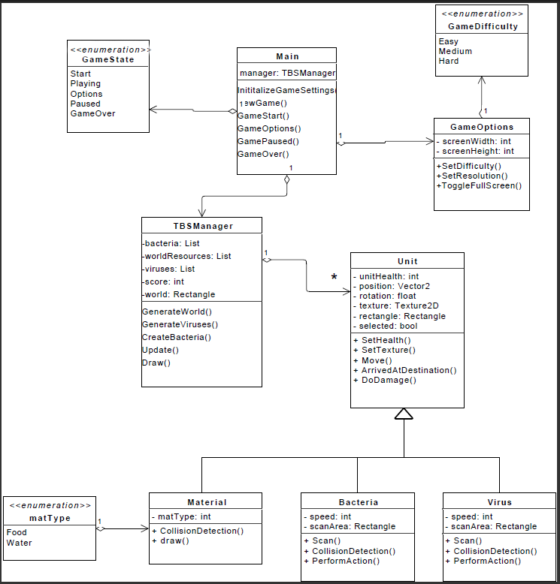*Class Diagram*

All the important classes and methods have been implemented and the game now functions as single player survival game where players play as bacteria.

There are randomly moving viruses on the map and the bacteria and viruses and attack each other when they are within their scan radius.

Bacteria take time to collect food and water. The players should move the bacteria over the resource and it will start absorbing it.

The score depends on how many resources you collect and how many viruses you kill.

Players can grow their bacteria to level 2. The bacteria will become bigger, have more health and do more damage, but move slower.

Players will use a mouse and keyboard to play the game. Following are some of the actions they can perform:

* Hold left click and drag to select units.
* Right click to move the units around in the world. Move the bacteria close to a resource to start absorbing it.
* The game has a top view and the players will control the camera with their mouse to determine which part of the world they can see.
* Use keyboard to spawn and grow the bacteria. Press ‘C’ to create bacteria and ‘L’ to level up or grow the selected bacteria.

The map is randomized each time the game starts i.e. the resources are placed at random locations and the viruses spawn at random locations every game.

The HUD displays the following information:

* Bacteria Population
* Virus Population
* Score
* Amount of Food and Water
* Health bar on top of each bacteria which shows its health

**Alpha Play-testing Evaluation Form**

Following is the feedback from the Alpha Release. A total of 17 people played and rated the game. The ratings are summarized in the following table.

|  |  |  |  |  |  |
| --- | --- | --- | --- | --- | --- |
|  |  | Strongly Agree (A) | Agree(B) | Disagree (C) | Strongly Disagree (D) |
| 1 | The core game mechanic is clear. | 7 | 6 | 4 |  |
| 2 | The game is easy to learn to play. | 5 | 8 | 4 |  |
| 3 | The menus and HUD (score, health, etc) are easy to understand. | 7 | 9 | 1 |  |
| 4 | The game feels "finished" or complete | 1 | 6 | 9 | 1 |
| 5 | This game is unique and creative, and does one thing well. | 7 | 10 |  |  |
| 6 | The game has no glitches or bugs. |  | 2 | 12 | 3 |
| 7 | The game is fun and engaging. | 4 | 10 | 3 |  |
| 8 | I would like to play the game again | 5 | 10 | 2 |  |

|  |  |  |  |
| --- | --- | --- | --- |
| 36 | 62 | 35 | 4 |

* The core game mechanic: The core game mechanic was clear to most of the people. There is still room for improvement in this area and we are constantly working to make it better.
* The game is easy to learn: Again many people agreed that the game was easy to learn to play. The ratings we got here is pretty good considering that there were many people who hadn’t played strategy before. We are planning to add instructions to help the player understand the gameplay and objectives and make the game easier to learn.
* The menus and HUD: We got good ratings in this category. Our menu and HUD were simple and displayed information relevant to the gameplay. We could improve it by adding a mini-map and nice fonts.
* The game feels "finished" or complete: Many people felt the game does not feel complete. We are still working on defining a clearer set of objectives for the player.
* This game is unique and creative: We got the highest ratings in this category. All the people thought that our game is unique and creative. Many people liked the animation of the bacteria and collecting resources.
* Glitches or bugs: The game had a few glitches/bugs which got us poor ratings in this category. The bacteria movement is bit frustrating. Also, while attacking, the player loses control of his units. These will be fixed in the beta release.
* The game is fun and engaging: 4 people strongly agreed, 10 people agreed and 3 disagreed. This is not bad considering the glitches in the gameplay. The game will be even more fun once we fix these bugs and balance the gameplay.
* I would like to play the game again: Out of 17 people, 15 people agreed that they would like to play the game again. This game has a lot of potential, and addressing the issues that people had while playing and improving and adding more features to the game would make it a success.

**What was the thing that you liked most about the game?**

People liked various aspects of the game. Following are the elements of the game that people liked :

No. of people that liked it

Simple Gameplay 3

Animation and Graphics 3

HUD 1

Collecting Resources 1

Unit Selection and Movement 3

Background 1

Challenging 1

**How easy/difficult is the gameplay?**

7 people found it easy to play the game, another 7 found it not too bad, and 3 people found it hard to play. Many people found the glitches to be frustrating, otherwise they found it easy to play.

**What changes would you like to make to the game? What features would you like to add or remove from the game?**

Add different bacteria classes/levels 4

Better animations for attacking or collecting 6

More freedom of movement 5

Show health of enemies 1

More options for spending resources 1

Better HUD 2

Music and sound effects 1

Everyone had something to add to the game. Many people suggested animations for collecting resources and attacking. Many of them also suggested improving the movement of bacteria and adding different classes of bacteria.

Overall, the response was positive and many people were interested in how the final game would turn out. The main issues that people had with the alpha release were the glitches with movement of bacteria which we are trying to fix right now. We are also planning to add more animations for attacking and collecting resources to make the game more attractive. Adding different levels of bacteria is already being worked on and the beta release will have atleast 2 levels of bacteria.